**Setup solution guide**

1. Clone or download solution from <https://github.com/yast77/seo-analyser-clement>
2. Build solution using Visual Studio, it will install required nuget packages at the first time when it build. (Note: This solution was created and developed using VS2017.
3. Make sure SEOAnalyser project is being set as Startup Project.

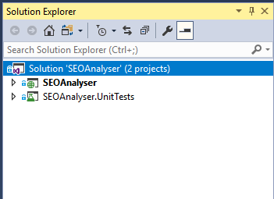

1. Press Ctrl+F5 to launch the SEO Analyser page, it should open up browser with the url <http://localhost:58220/>

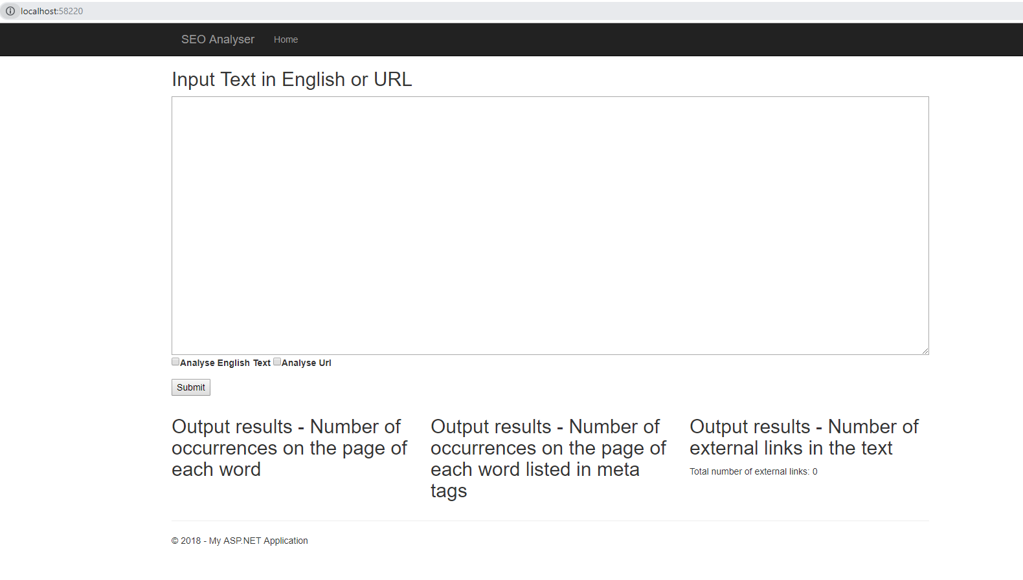

**User guide**

1. Below figure explain the basic description of the page.



User input, either Text in English or URL

Analyse option, choose either Analyse English Text or Analyse Url

Submit button to process based on user input

Three different SEO analysed output results in table mode

1. In order to analyse English Text, input text into the textarea, check “Analyse English Text” option, and then click the Submit button, it should show the results as below.

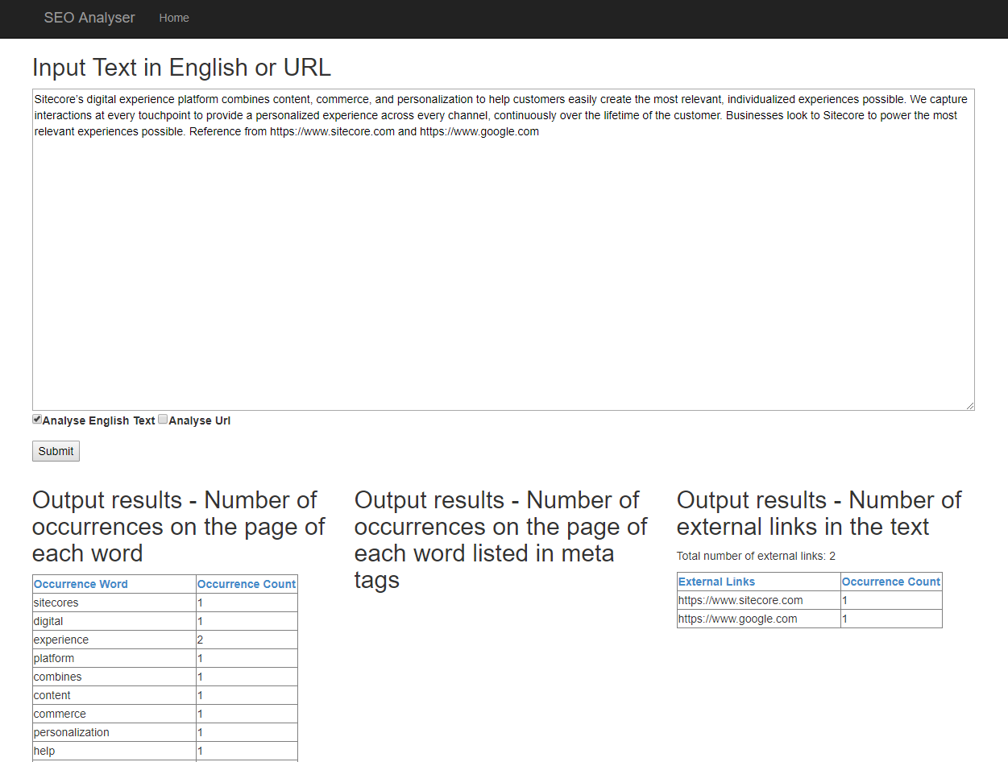

1. Table results can be sorted by clicking table header with blue colour fonts.
2. In order to analyse Url page, input url into the textarea, check “Analyse Url” option, and then click the Submit button, it should show the results as below.

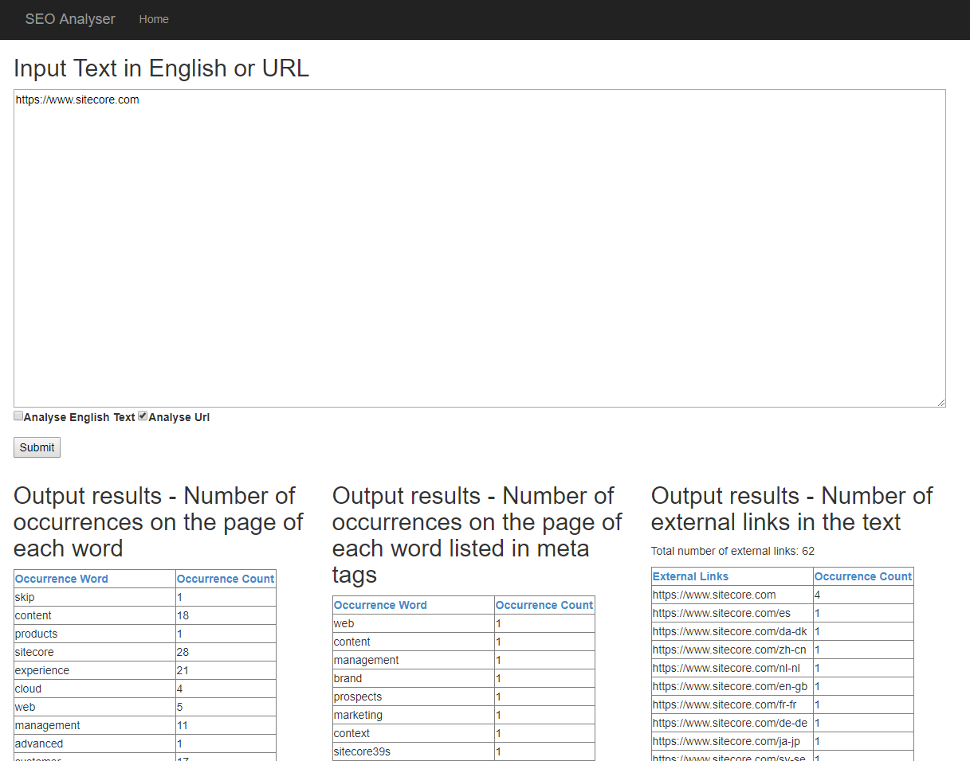

1. Table results also can be sorted by clicking table header with blue colour fonts